Caerleon Governors’ Annual Report to Parents & Carers
  - 2021 - 2022

Sicrhewch Ragoriaeth
Maximising Potential
  - Letter from the Chair of Governors
Dear Parent/Carer,
As the Chair of Governors at Caerleon Comprehensive School, I am delighted to present the Annual Report to Parents for the academic year 2021-2022.
During the academic year 2021-2022, the school was working hard to embrace all COVID-19 guidance from Welsh Government. Consequently, in line with government guidance, this report does not include information relating to performance, targets and results. Despite its comparative brevity, we hope this report gives you a ‘flavour’ of the 2021-2022 academic year at our school.
‘Maximising potential’ governs all aspect of school life at Caerleon. As school governors we are proud of our school community at Caerleon. In line with our school motto, staff work tirelessly to maintain high standards. They challenge our young people to ensure that they achieve excellent results and support them to ensure they feel safe and happy. Our aim is to support all learners so that they mature into responsible, caring citizens.
On behalf of the Governing Body I would like to thank our Headteacher, Mrs Picton, and her excellent team for all their hard work and dedication.
If you have any questions relating to the report, then please do not hesitate to contact the school.
Dr Paul Warren
Chair of the Governing Body

Annual Report to Parents
  - 2021 - 2022
Table of Contents
1 Introduction 5
1.1 About this report 5
1.2 Parents’ meeting 5
2 School Information 6
2.1 Term dates 6
2.2 School prospectus 6
The school produces an online prospectus for the 2021-2022 school year. You may download this and other publications from the web site. 6
2.3 Language category 6
3 School Life 7
3.1 Teaching and learning 7
3.1.1 Curriculum – Years 7 to 9 7
3.1.2 Key Stage 4 curriculum 9
3.1.3 Post-16 curriculum 10
3.1.4 Additional Needs 10
3.2 Wellbeing 11
3.2.1 Healthy eating 11
3.2.2 Welfare 11
3.2.3 Behaviour management 11
3.2.4 Learning Pathways 11
3.3 Learner and parent voice 12
3.3.1 Parent forum 12
3.4 Extra-curricular activities 12
3.5 Community and external links 13
3.5.1 Educational Visits 13
3.5.2 School Fundraising 13
3.6 Facilities 13
3.6.1 Buildings 13
3.6.2 Accessibility 14
3.6.3 Toilets 14
4 People 15
4.1 Learner destinations 15
4.2 Staff 16
4.2.1 Organisation 16
4.3 Governors 16
4.3.1 Chair 16
4.3.2 Members 17
4.3.3 Clerk 17
4.3.4 Governor activities 18
4.3.5 Policy and strategy review 18
4.3.6 Elections 18
5 Finance 19
6 Appendix 20
6.1 Glossary 20

Introduction

About this report
This report is produced by the governing body for the parents and carers of students at Caerleon Comprehensive School.
The report covers the 2021-22 academic year and provides a snapshot of the school. We believe it will be of interest to you if you have a child at the school or if you are considering applying for your child to join us.

Parents’ meeting
Parents are welcome to request a meeting with the governing body to discuss this report.
Parents have a statutory right to such a meeting, subject to these conditions:
- A petition with the signatures of at least 30 parents is raised.
- The meeting is to discuss school-related matters.
- There are no more than three of these meetings in a school year.
- There are at least 25 school days left in the school year.

School Information

Term dates
Term | Start | Half term | End
Autumn | 02/09/2021 | 25/10/2021 to 29/10/2021 | 20/12/2021
Spring | 03/01/2022 | 21/02/2022 to 25/02/2022 | 11/04/2022
Summer | 25/04/2022 | 30/05/2022 to 03/06/2022 | 22/07/2022

School prospectus

The school produces an online prospectus for the 2021-2022 school year. You may download this and other publications from the web site.
Hard copies are available on request.

Language category
Caerleon Comprehensive School is an English medium school.

School Life

Teaching and learning

Curriculum – Years 7 to 9
Following a review undertaken by Professor Graham Donaldson in 2015, Wales is preparing for significant educational reform for 3-16 year olds, designed to put literacy, numeracy and digital competence at the heart of the system.
Improving education is our national mission. There are four purposes of the curriculum for Wales. All our children and young people will be:
- ambitious, capable learners
- enterprising, creative contributors
- ethical, informed citizens
- healthy, confident individuals
These four purposes are the shared vision and aspiration for every child and young person.
‘Key Stages’ will disappear and replaced with a seamless curriculum for children aged 3-16, providing more joined-up learning. Traditional subjects will still be taught but they will be grouped into six ‘Areas of Learning Experience’ (AoLEs):
- Languages, Literacy and Communication
- Mathematics and Numeracy
- Science and Technology
- Expressive Arts
- Humanities
- Health and Wellbeing
There are 27 statements of ‘what matters’ across the six area of learning experience and these will be used to construct the curriculum for our learners.
We are in a transitions phase between the need to deliver the National Curriculum and prepare for the new Curriculum for Wales. Since September 2020, departments have been trialling new learner experiences and investigating how new ‘progression steps’ will link in with this work.
In light of the COVID-19 pandemic, the Welsh Government has allowed schools to defer implementation of the new curriculum by one year to September 2023 at which point both year 7 and year 8 will need to follow the new curriculum. We will not be taking up the option of deferring implementation by a year. The new curriculum will be taught to year 7 from September 2022 and then roll out year by year.
The school has been and will continue to engage with stakeholders in order to prepare for this exciting change and it is anticipated that this current curriculum policy will be modified to fully embrace ongoing developments in the new curriculum.
Our current school curriculum:
- focuses on the learner
- ensures that appropriate skills development is woven throughout the curriculum
- offers reduced subject content with an increased focus on skills
- focuses on continuity and progression
- is flexible in order to meet the needs of all learners
supports Government policy, including bilingualism, Cwricwlwm Cymreig/Wales, Europe and the World, equal opportunities, health and wellbeing, sustainable development and global citizenship, Careers and the world of work
- continues to deliver a distinctive curriculum that is appropriate for Wales
Students are expected to acquire skills in:
- speaking and listening, literacy, numeracy skills and digital competence, working with others and problem solving
- personal, social and health education reflecting the school’s aims and ethos

Subjects in years 7 to 9 are taught in mixed-ability groups with the exception of D&T, PE and mathematics in year 9.
The following table shows the list of subjects taught, and number of lessons per fortnight allocated to each across KS3 for the 2020-21 school year. In years 8 and 9 students have the opportunity to study German as their second modern foreign language.

Subject lessons per fortnight | Year 7 | Year 8 | Year 9
Art | 2 | 2 | 2
Biology |  | 2 | 2
Chemistry |  | 2 | 2
Design & Tech. | 4 | 3 | 3
Drama | 1 | 1 | 1
English | 6 | 6 | 7
French | 3 | 3 | 3
Geography | 3 | 3 | 3
German | N/A | 1 | 1
History | 3 | 3 | 3
I.T. | 2 | 2 | 2
Maths | 6 | 6 | 7
Music | 2 | 2 | 2
P.E. | 4 | 5 | 4
Physics |  | 2 | 2
P.S.E. | 2 | 2 | N/A
R.E. | 3 | 2 | 2
Science | 6
Welsh | 3 | 3 | 3
Finance | N/A | N/A | 1

Key Stage 4 curriculum
At Key Stage 4, students select a smaller number of subjects; the school provides guidance in order that students choose a range of subjects which is appropriate to their needs, and those in which they can do well. All pupils access one-to-one subject counselling with a member of senior staff.
The following table shows the full list of subjects that were available in KS4 in 2021-2022.
Compulsory Subjects | Option Subjects
English | Art
Maths | French
Science | German
Welsh | ICT
RE | Sociology
RSE | Work Skills
PE | History
WBQ L2 | PE
 | Welsh
 | Geography
 | Food and Nutrition
 | Engineering
 | Drama
 | Health and Social Care
 | D&T Product Design
 | D&T Textiles
 | D&T Graphic Products
 | Business Studies
 | Music
 | Creative and Media

In core subjects, students are taught in sets according to ability. They will be expected to take external examinations during and at the end of the KS4.

Post-16 curriculum
In the Sixth Form, students study either three or four subjects at AS level in year 12 (including Welsh Baccalaureate). If a course is not available in school, students may still be able to access it via another school as part of the Newport collaborative programme. The school works closely with Llanwern as its “preferred partner”.

The following table shows the full list of subjects that were studied in 2021-22.
Compulsory Subjects | Year 12 and 13 Subjects | Collaborative Subjects
WBQ L3 | Chemistry | Sport
 | Biology | Photography
 | Physics | Applied Science
 | Design and Technology | Music Performance
 | Geography | Media Studies
 | Mathematics | Health and Social Care
 | Double Mathematics | Business Studies OCR
 | German | Financial Studies
 | Music
 | Sociology
 | English Language
 | English Literature
 | Psychology
 | RE
 | Theatre Studies
 | History
 | ICT
 | Art & Design
 | Business Studies
 | French
 | PE
 | Welsh

Additional Needs
Caerleon Comprehensive School is committed to providing an individualised, high-quality education to all our students. We believe that all students, including those identified as having additional learning needs (ALN) have a common entitlement to a broad and balanced academic and social curriculum, which is accessible to them and to be fully included in all aspects of school life.
In 2021 – 22 the interventions programme was embedded across a range of abilities, with ALN students being given the opportunity to undertake extra Literacy and Numeracy as part of a paired buddy scheme. Additionally, our small-group provision removed the need for ALN learners to study a second modern foreign language (German). Our ALNCO, Mrs D Davies, leads our ALN team.

Wellbeing

Healthy eating
A School Nutrition Action Group (SNAG) made up of students representing a cross section of year groups and dietary needs met every half term. Their feedback has been used by Aspens, the school catering partner, to improve provision.
The SRE and PE curricula, enrichment activities and the food technology curriculum support healthy eating and living.

Welfare
The Assistant Head Teacher for Wellbeing manages the Heads of Year (HOY), and holds:
- fortnightly meetings with HOYs 7-11 (attendance and bullying/behaviour are mandatory agenda items); and
- termly full pastoral meeting
- From tutors meet with their Head of Year on a weekly basis.
The AHT Wellbeing also manages the ALNCO, AAHT (Learning Centre), 3 Learning Coaches and 1 Pastoral Support Officer. These staff meet regularly to support students who require additional pastoral care and interventions.

Behaviour management
The school has a Behaviour for Learning policy which defines expectations and sanctions and encourages pupils to take ownership of and responsibility for their own behaviour management. This is available on the school website.

Learning Pathways
The school continues to develop the options selection process at levels 2 (e.g. GCSE) and 3 (e.g. A Level). We work alongside students to make sure that they select the subjects which help them maximise their potential and prepare them for the world of work, further education and school/college and for higher education pathways.
The main features are:
- Year 9 and 11 Students are given a free choice of subjects to study the following year. The timetable is built around those choices, to maximise the number of students able to study all their preferred subjects.
- The school provides one-to-one support for every student, to help each one choose their most effective combination of subjects.

Learner and parent voice
Feedback from student surveys contributes to the school’s self-evaluation process. Learner voice groups also informs school decision making in areas such as wellbeing support, teaching and learning, nutrition and health and ecological issues.
The School Council continues to have an influence on school development. The opinions of student councillors are sought on a whole range of issues. Each form is represented by two councillors who sit on a Year Council. In turn each year group has two representatives on the School Council.

Parent forum
The objective of our Parent/Carer Forum is to facilitate positive and productive two-way communication between parents/carers and the school, providing a channel for consultation, feedback, and suggestions for improvement. All parents are welcome to attend. The dates of future parent forums can be found on the school web site.

Extra-curricular activities
The school offers its students a wide range of extra-curricular activities, which many take advantage of. Each year the offering is reviewed and updated.
Activity | Years
String Orchestra | All
Senior Choir | Y9-13
Sixth Form Choir | Y12-13
Senior Orchestra | All
School Wind Band | All
Junior Choir | Y7-8
Big Band | Invited players
Percussion Ensemble | All
Composition Club | All
Rugby | All
Football | All
Hockey | All
Netball | All
Cross-country | All
Gymnastics | All
Dance | All
Tennis | All
Indoor Rowing | All
Athletics | All
Cricket | All
Rounders | All
Golf | All
Library Carnegie Reading Group | Y7-8
Library – Quiz Club | Y7-8
French – National Spelling Bee Competition | Y7
Fair trade group | Y7-9
Welsh – Lunchtime Club | Y7
UK Maths Challenge Competition | All
After School Art Club | All
Duke of Edinburgh – Bronze and Silver | All
Drama Club
STEM | All
Textiles Club | Y12
Debating Club | All
History Catch Up Sessions | All
After School Youth Club | Y7-8

Community and external links
The school has numerous community and external links including:
- Links to local businesses through ‘Business Class’
- Our partnerships with a number of partner schools through the EAS Learning Networks
- Links with the police through our allocated liaison officer
- Local charities and organisations
- Our partnership with Cardiff Metropolitan University to deliver teacher training
- Our partnership with Coleg Gwent and ACT to offer curriculum support to learners who require an alternative learning pathway
- Various partnerships offering mental health support to young people

Educational Visits
During the 2021-22 academic year, the school, in line with Welsh Government and Local Authority COVID-19 advice, was unable to offer educational visits

School Fundraising
The school is grateful for the support of The Friends of Caerleon Comprehensive School, the local community and businesses in making donations to the School Fund.

Facilities

Buildings
The 21st Century Schools Band B Programme has commenced (Project Manager assigned, workshops held, conditioning surveys carried out). The objective of this initiative is primarily to replace existing demountables and indoor sports facilities with a new teaching block. It is anticipated that work will commence in 2022.

Accessibility
Where required, wheel chair ramps are fitted to building entrances. The main building and Isca block have a lift. Uneven paving slabs and loose drain covers are repaired/replaced as required.

Toilets
There are separate toilet facilities for male and female, students and staff. Disabled toilets are also available. Cleaning is carried out daily during and at the end of the school day. Should it be necessary, staff on site can deal with emergency cleaning during the day.

People

Learner destinations
Destinations, Caerleon Comprehensive, 2022 (Careers Wales):
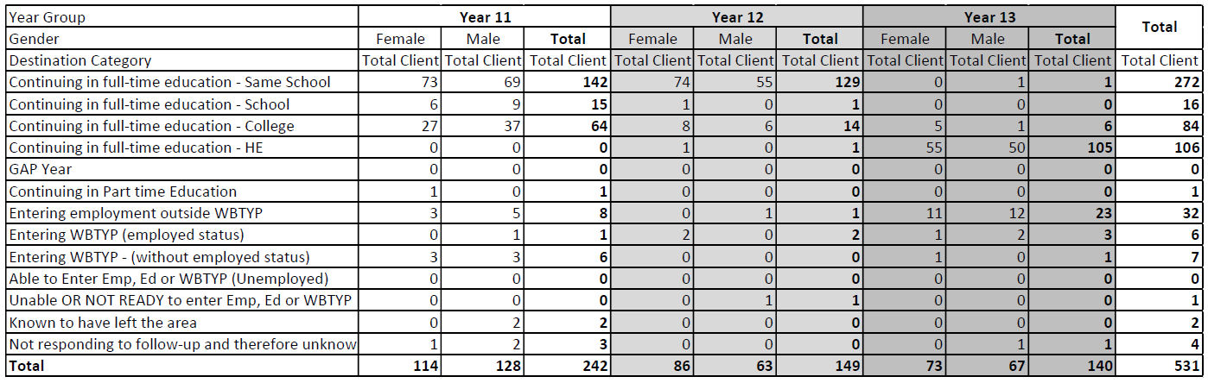
During the academic year of 2021-2022, there were 137 students in Year 13, of which 115 (comprising 83% of the total students) applied for university admission. Within this cohort, one student was successful in securing a place to study medicine. It is noteworthy that 90% of these students were granted admission to their firm or insurance choice institutions, whereas the remaining 10% either entered the clearing process or opted to defer their enrollment for one year.
Furthermore, 36% of the students who proceeded to university were admitted to prestigious Russell Group institutions. The remaining 22 students in Year 13 pursued various paths. One student enrolled in a music conservatoire, another student commenced an Art Foundation course, and six students embarked on apprenticeships at esteemed organisations, including BAE Systems, the Royal Air Force, Celtic Manor, and Deloitte. Additionally, eight students deferred their university applications for a year and have now applied with notable offers in dentistry and medicine. The remaining students pursued employment opportunities or continued their education at local colleges.

Staff

Organisation
Headteacher: Mrs L Picton Deputy Headteacher: Mr G Jones
Assistant Headteacher Wellbeing: Mr A Gardner
Assistant Headteacher Standards: Mr P Harriman
Assistant Headteacher Teaching & Learning: Chris Maidment
Assistant Headteacher Communities & Partnerships: Emma Wilson

Governors

Chair
Dr Paul Warren
c/o Caerleon Comprehensive School, Cold Bath Road, Caerleon, Newport, NP18 1NF

Members
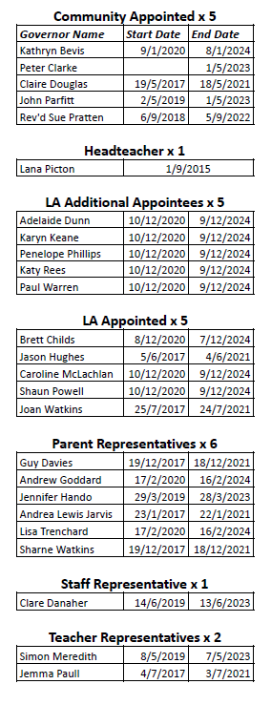

Clerk
Clerk to the Governing Body at Caerleon Comprehensive School
Education Achievement Service for South East Wales
Tredomen Gateway
Tredomen Park
Ystrad Mynach
Hengoed
CF82 7EH

Governor activities
No governors claimed for travelling or subsistence expenses during the year.

Policy and strategy review
The Governing Body’s committees consider and review changes to school policies, many of which exist to fulfil statutory requirements. Many of the school’s policies are publicly available on the school’s web site, and the rest are open to inspection by parents by prior arrangement.
The committee follows a review timetable to ensure every school policy is regularly reviewed and updated.

Elections
When a vacancy arises on the governing body for a parent representative, the Local Authority will inform all parents of the vacancy and arrange for an election. Every parent of a registered student at the school will be entitled to stand as a candidate and will be sent a letter with a nomination form. The form, including a personal statement, must be returned to the school by the set date. If there are more nominations than vacancies, then the election will be decided by secret ballot.

Finance
Statement for 2021-2022 academic year:
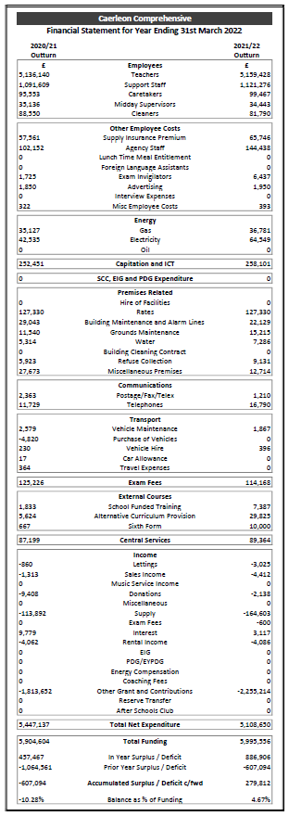

Appendix

Glossary
The education system is full of jargon. We have minimised our use of it in this report, however, it is hard to avoid completely. Please see the glossary below which we hope will be of use:
AfL | Assessment for Learning
AHT | Assistant Headteacher
AAHT | Associate Assistant Headteacher
BfL | Behaviour for Learning
CTG | Close the Gap; an approach to marking work that includes overall “what went well” (WWW) and “even better if” (EBI) comments.
DCF | Digital Competency Framework
EAS | Educational Achievement Service
ESDGC | Education for Sustainable Development and Global Citizenship
GCSE | General Certificate of Secondary Education
HoY | Head of Year
KS2 | National Curriculum Key Stage 3; years 7-9
KS3 | National Curriculum Key Stage 4; years 10-11
KS5 | National Curriculum Key Stage 5; years 12-13
LSB | Learning Support Base
MAT | More Able and Talented
MOSSS | Model of Secondary Schools Support
PDG | Pupil Deprivation Grant
PSE | Personal and Social Education
SIMS | School Information Management System: a computer system which holds information about the school and its students, including targets and levels of achievement
SNAG | School Nutrition Action Group
SSSP | Summary of Secondary School Performance
STEM | Science, Technology, Engineering and Maths
Sutton 30 | The 30 most-selective British universities
UCAS | Universities and Colleges Admissions Service
WBQ | Welsh Baccalaureate Qualification

