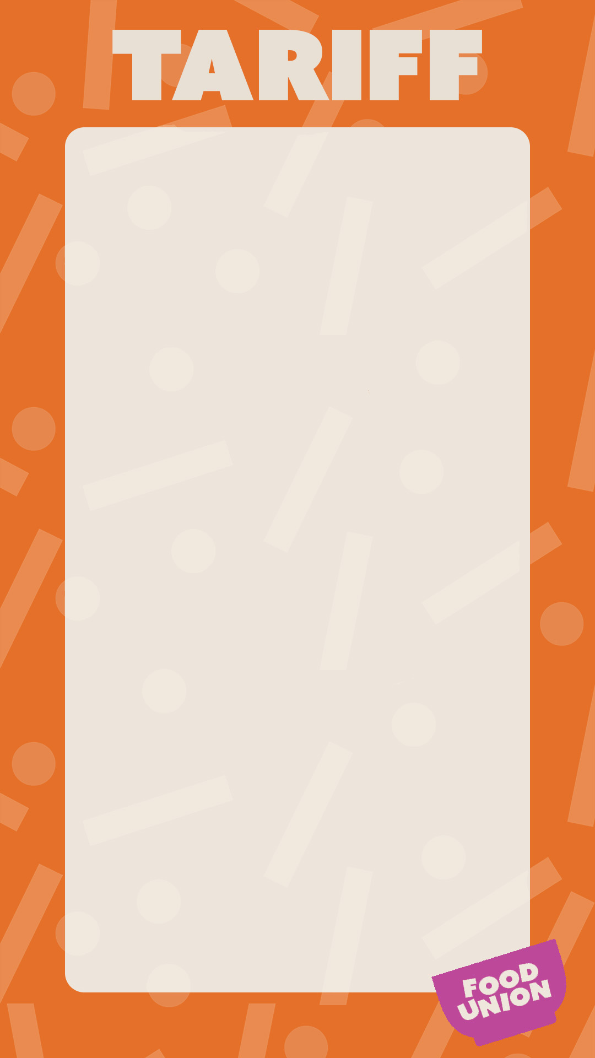

MID-MORNING BREAK

Buttered Toast (X1) £0.35

Buttered Crumpets £0.57

Bacon Baguette £2.48

Sausage And Cheese Muffin £2.12

Egg and Spinach Muffin £2.12

Cheese And Bean Toastie £1.70

Pizza Bagel £1.40

Cheesy BBQ Pretzel £1.25

Chicken Wings £1.60

Waffle £1.30

DRINKS

BAGUETTES, SALADS & SANDSWICHES

Water 330ml £0.74
Water 500ml £0.95
Radnor Water £1.00
OMJ Carton £1.10
OMJ Can £1.20
Suso Can £1.15
Viva Milkshake £0.78
Yazoo Milkshake £1.30
Appletiser £1.30

All Wraps £2.15
Basic Sandwich £1.72
Premium Sandwich £1.92
Basic Baguette £1.77
Premium Baguette £2.24
Indian Chickpea Salad £2.08

GRAB AND GO SNACKS
PASTA POTS

Mini Cheddars £1.05
Oreo’s £0.90
Digestives £0.90
Basic Tray Bake £0.95
Premium Tray Bake £1.05
Cookie £1.05
Granola Pot £1.20
Crudites £1.10
Mousse Pot £1.05
Fruit Pots £0.90
Piece Of Fruit £0.80
Pesto Pasta (cold) £2.07
Tuna and Sweet Corn £2.07
Plain Pasta £1.90
Pasta + One Topping £2.10
Pasta + Two Toppings £2.47

GRAB AND GO HOT

Pizza Slice x 1 £1.40
Jacket Potato Plain £1.05
Jacket Potato x 1 Filling £2.21
Jacket Potato x 2 Fillings £2.47
Solo Panini £2.11
Premium Panini £2.37

MAIN MEAL

£2.68

MAIN MEAL DEAL

£3.30

Includes dessert or Drink

